**Internship Project Report**

**Project Report**

on

**E-commerce Website Development**

**Project Title:** E-commerce Website – Gadget Avenue

## Submitted To



**Vaidsys Technologies**

Submitted By

Siddhi Ananda Thorat

# INDEX

|  |  |  |
| --- | --- | --- |
| **SR.NO.** | **Chapters** | **Page No.** |
| 1 | Abstract | 3 |
| 2 | Introduction | 4 |
| 3 | Objectives of Project | 6 |
| 4 | Software & Tools Used | 7 |
| 5 | System Architecture | 8 |
| 6 | Features Implemented | 9 |
| 7 | UI Screenshots of Project | 11 |
| 8 | Testing | 13 |
| 9 | Future Enhancements | 15 |
| 10 | Conclusion | 17 |

1. **Abstract**

The project titled **"Gadget Avenue"** is a full-stack E-commerce web application developed to provide users with a seamless online shopping experience for electronic gadgets such as mobiles, laptops, headphones, and accessories. The website features a modern and responsive user interface built using **React.js** and **Bootstrap**, ensuring accessibility across devices. The backend is powered by **Node.js** and **Express**, while **MongoDB** is used for secure and scalable data storage.

The application supports essential functionalities such as user registration and login, product listing, add to cart, view cart, and a payment page. Dummy data has been used for testing and interface validation, with scope for future integration of real-time payment gateways. The project demonstrates the complete development lifecycle of an online shopping platform using the **MERN stack**, incorporating real-world development practices such as modular coding, API communication, and database interaction.

This project helped in enhancing practical knowledge of full-stack web development, understanding of e-commerce workflows, and solving challenges related to user interaction, UI/UX design, and backend integration.

1. **Introduction**

In today’s digital era, online shopping has transformed the way consumers purchase goods and services. E-commerce platforms offer convenience, variety, and speed, making them essential in modern business environments. Recognizing this growing demand, the project **"Gadget Avenue"** was conceptualized and developed as a responsive, user-friendly e-commerce website dedicated to selling electronic gadgets.

**Gadget Avenue** is designed to provide users with a smooth and interactive shopping experience for gadgets such as mobiles, laptops, headphones, and accessories. The application focuses on intuitive navigation, product browsing, and streamlined cart and checkout processes. It simulates a real-world e-commerce environment by incorporating all the key features that a user would expect in a modern online store.

This project was developed using the **MERN stack (MongoDB, Express.js, React.js, Node.js),** a popular technology stack for building dynamic, single-page applications. React.js is used to build the front-end with reusable components, while Node.js and Express.js handle backend operations and server-side logic. MongoDB is employed as a NoSQL database to manage and store user and product data securely.



The main objective of this project is not only to develop a fully functional e-commerce platform but also to enhance the developer’s understanding of full-stack development, database connectivity, user authentication, and RESTful API integration. Through this project, key concepts such as component-based architecture, state management, routing, and backend API handling have been practically applied.

**Gadget Avenue** represents a real-world implementation of modern web development skills and demonstrates how technology can be used to create efficient and scalable online shopping platforms.

1. **Objectives of Project**

The primary goal of the "Gadget Avenue" project is to design and develop a fully functional and user-friendly E-commerce web application that allows users to browse and purchase electronic gadgets online. The project aims to implement key features of modern online shopping systems while utilizing full-stack development technologies.

The specific objectives of the project are:

1. To design a responsive and interactive user interface using React.js and Bootstrap for smooth navigation across devices like mobile, tablet, and desktop.
2. To implement user authentication including registration and login functionalities, ensuring secure access to the website.
3. To develop dynamic product listing pages that display various categories like mobiles, laptops, headphones, and cables with the ability to browse and search products.
4. To implement cart functionality, allowing users to add, remove, and manage products before proceeding to checkout.
5. To build a dummy payment page to simulate the checkout process and demonstrate the complete flow of an online purchase.
6. To integrate a backend server using Node.js and Express.js to handle user requests, process data, and connect with the database.
7. To use MongoDB as the database for storing and managing user information, product details, and cart data efficiently.
8. To understand and apply RESTful API development for communication between frontend and backend systems.
9. To follow modern development practices, including component-based design, modular architecture, and version control using Git.
10. To gain practical knowledge of the MERN stack and enhance problem-solving, debugging, and full-stack integration skills.
11. **Software & Tools Used**

The development of **Gadget Avenue** involved several software tools and technologies that contributed to both the frontend and backend of the application. The following table lists the key tools and their purposes:

|  |  |
| --- | --- |
| Tool / Technology | Purpose |
| React.js | Frontend development using component-based architecture |
| Bootstrap | Responsive and styled UI design |
| Node.js | Backend runtime environment for executing JavaScript on the server |
| Express.js | Backend framework for building RESTful APIs |
| MongoDB | NoSQL database for storing user, product, and cart data |
| Mongoose | ODM (Object Data Modelling) library to interact with MongoDB |
| Visual Studio Code | Code editor used for writing and organizing code |
| Postman | API testing tool used to test HTTP requests and responses |
| Google Chrome DevTools | Debugging and UI testing in the browser |

1. **System Architecture**

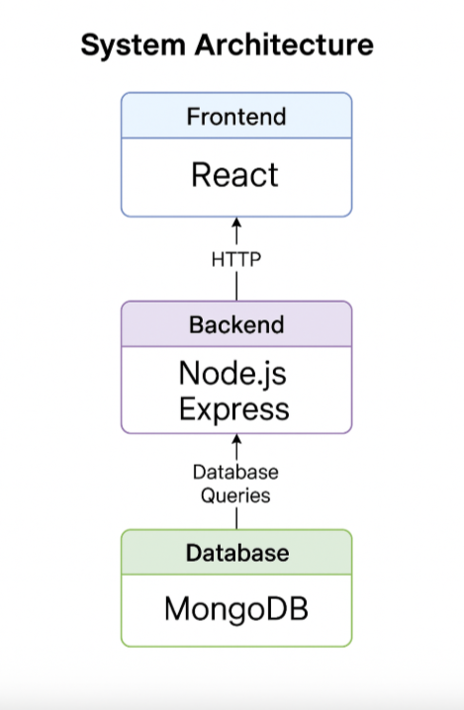

1. **Features Implemented**

The following key features were successfully implemented in the E-commerce Website **“Gadget Avenue”** to enhance functionality, usability, and user experience:

### ****User Authentication****

* User “**registration”** form with input validation.
* Secure **login** functionality with proper error handling.
* User data stored securely in “**MongoDB”**.

### ****Product Listing****

* Display of products under categories: “**Mobiles, Laptops, Headphones**,and **Cables”**.
* Each product card shows image, title, description, price, and rating.
* Dynamic rendering of product details.

### ****Search Functionality****

* Integrated search bar for real-time product filtering by name or category.

### ****Add to Cart Feature****

* “Add to Cart” option available on both product and home pages.
* Cart page displays added products with details (image, name, price).
* Functional **“Buy Now”** and **“Remove”** buttons for each cart item.
* Item count displayed on cart icon in the navbar.

### ****Buy Now and Payment Page****

* “Buy Now” button redirects to a dedicated **Payment Page**.
* Dummy payment gateway with form validations and confirmation popup.

### ****Responsive User Interface****

* Mobile-friendly, responsive design using **React** and **Bootstrap**.
* Consistent color schemes, iconography, and modern layout.

### ****Navigation Bar****

* Sticky navbar with links to “**Home, Products, Cart, Login/Register”**.
* Cart icon displays dynamic count of items added.

### ****Database Integration****

* Backend powered by “**Node.js”** and “**Express.js”**.
* MongoDB used to store user registration and login credentials.
* RESTful API used to communicate between frontend and backend.

### ****Error Handling and Validations****

* Proper client-side and server-side form validations.
* Clear feedback messages for successful actions or errors.

1. **UI Screenshots of the Project**

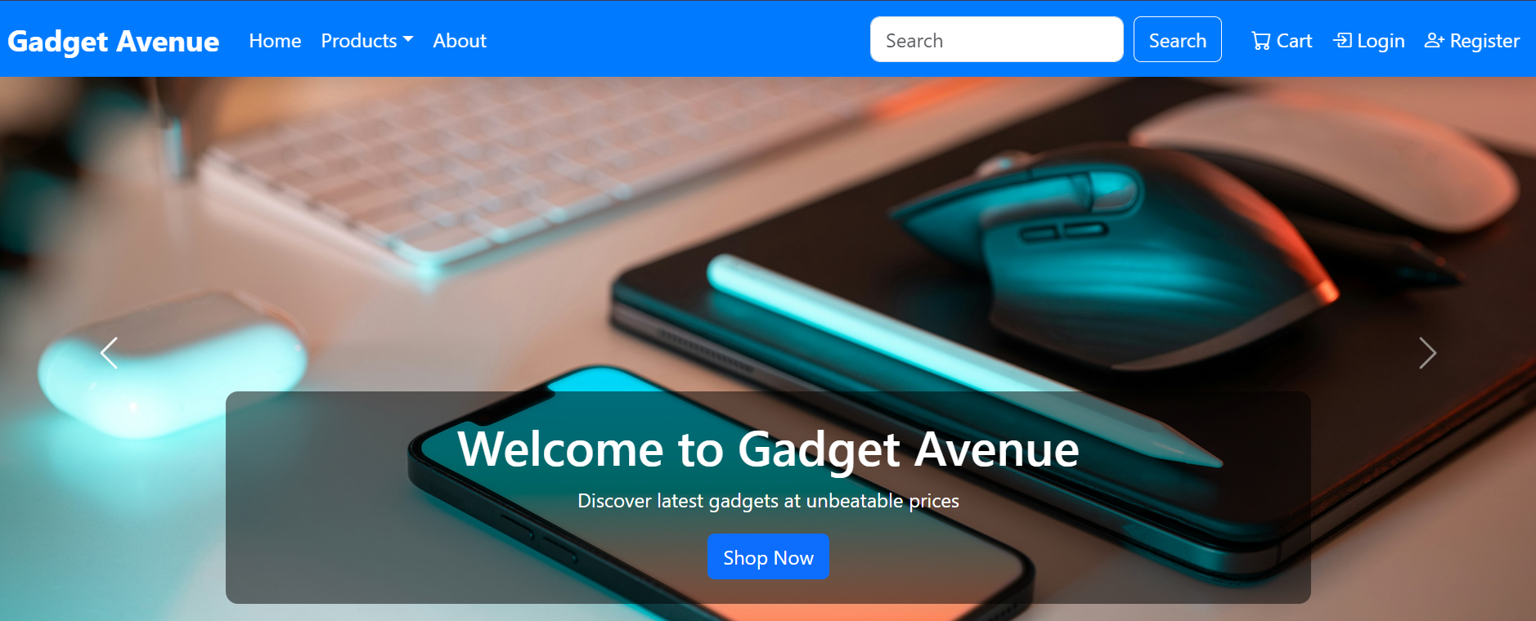

Figure : Hero Section

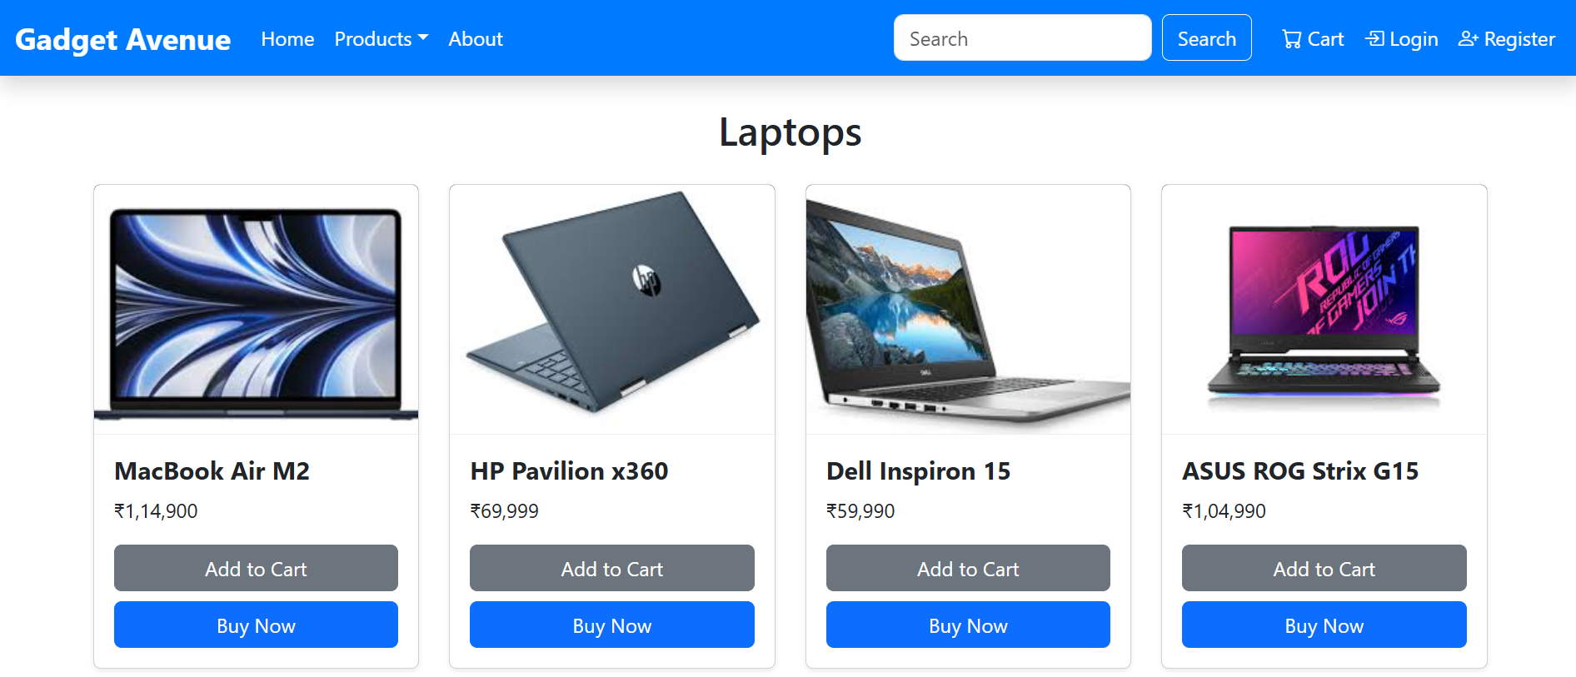

Figure : Product Page

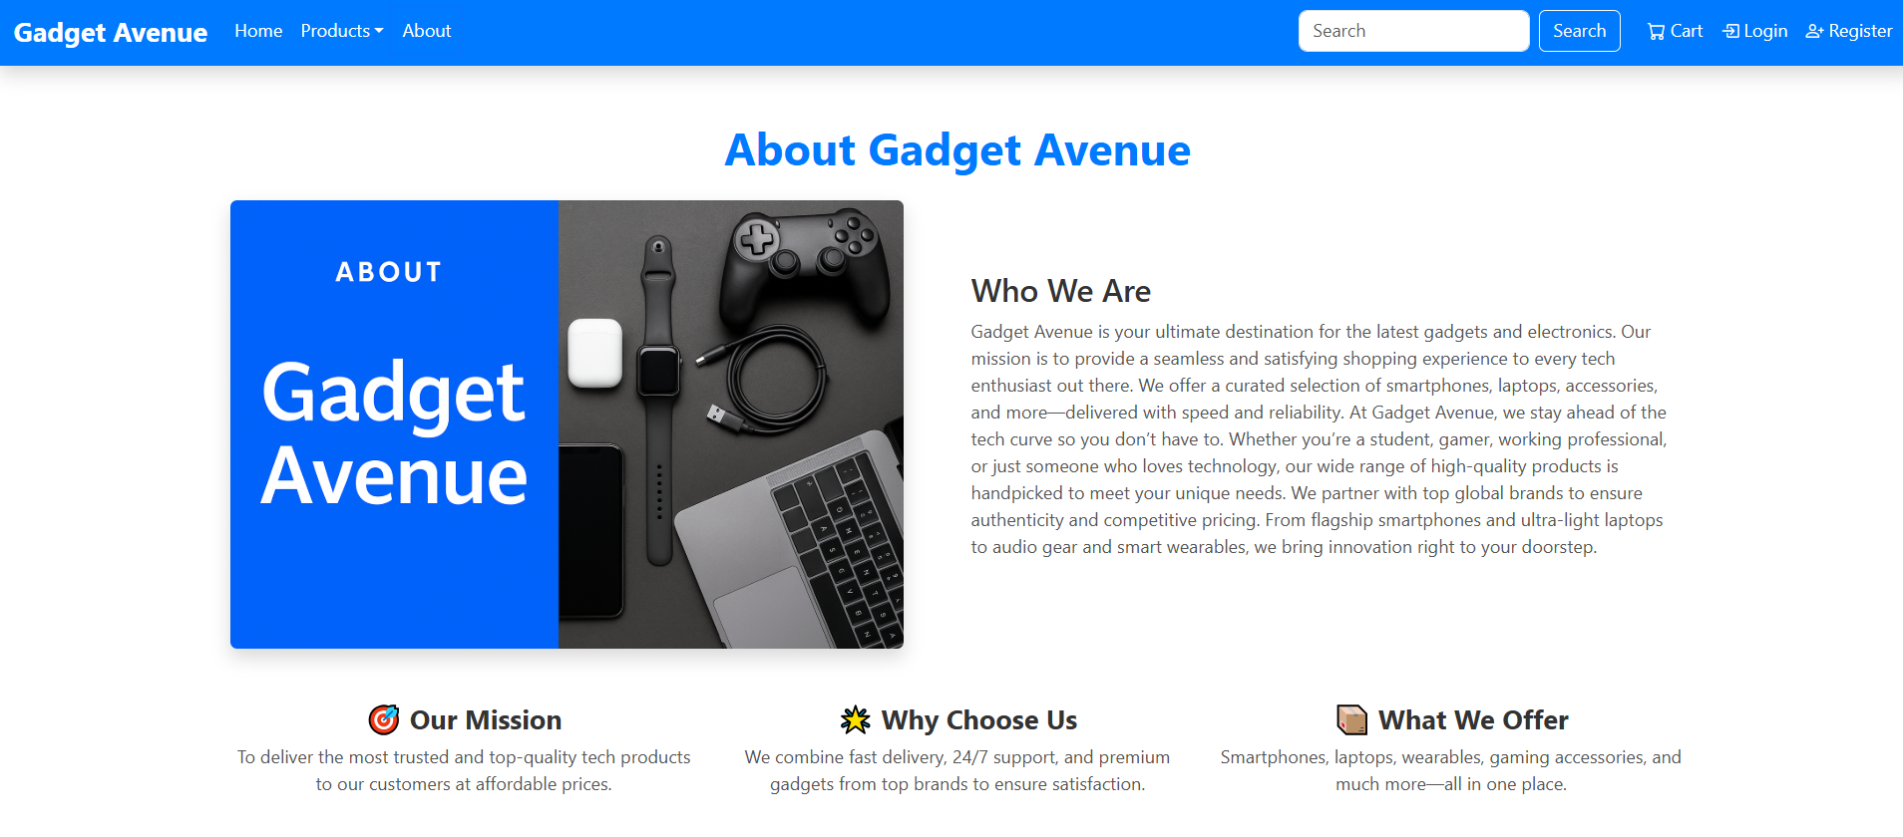

Figure : About us Page

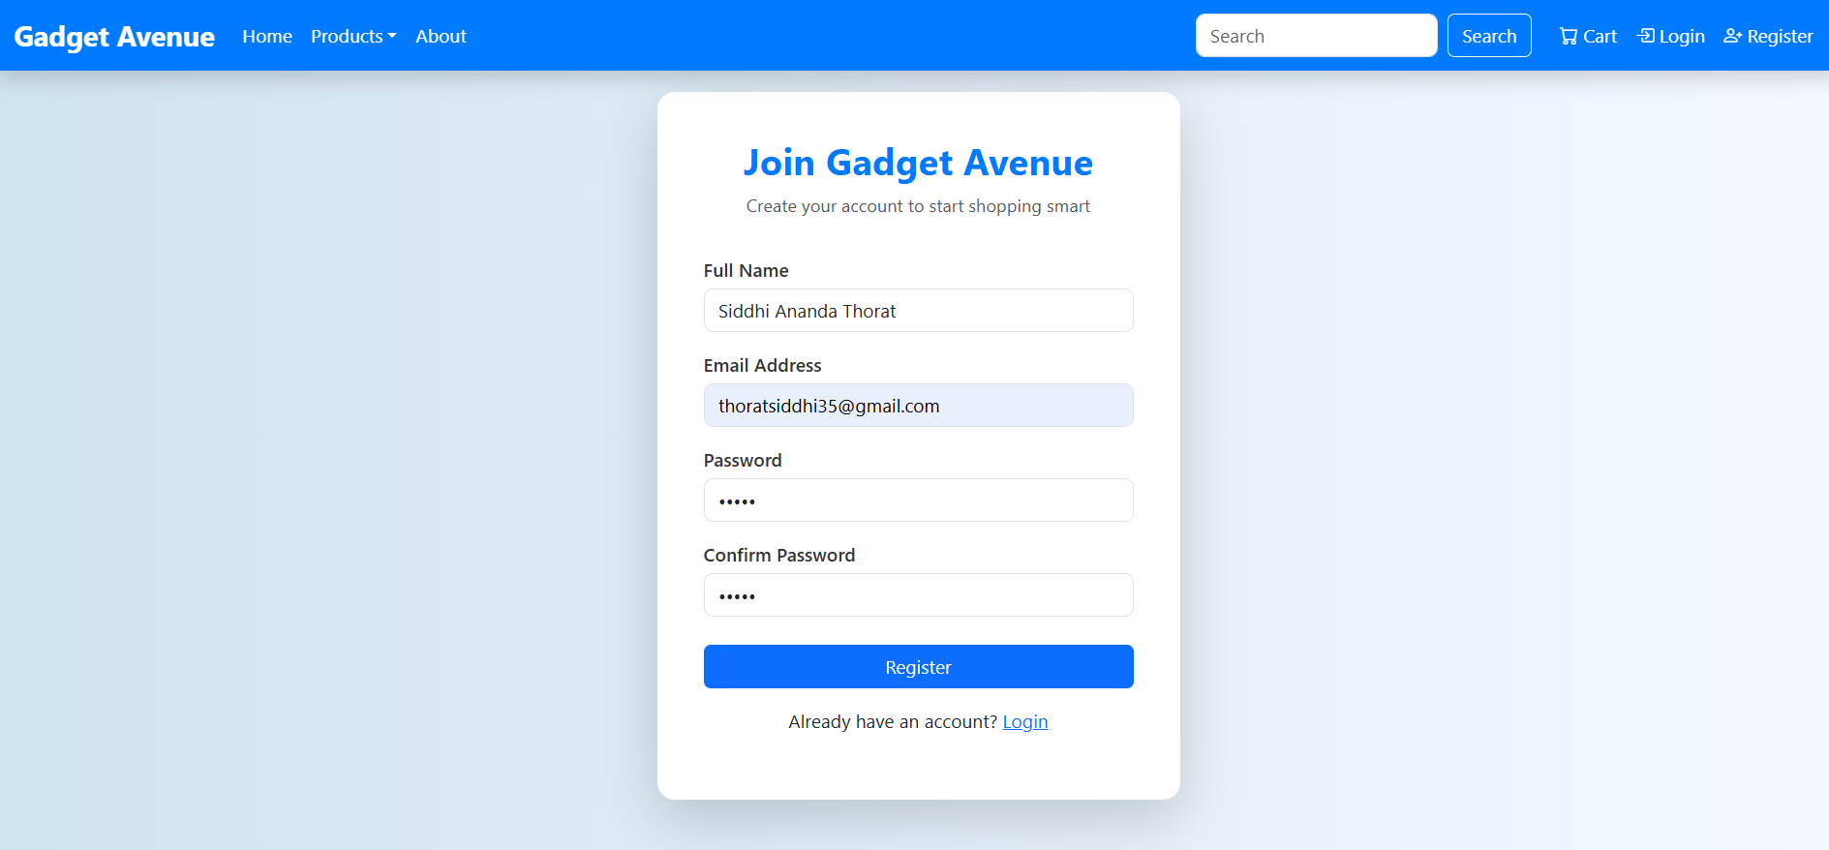

Figure : Registration Page

1. **Testing**

Testing is a crucial phase in the software development lifecycle, ensuring that all functionalities of the application work as expected and provide a seamless user experience. The **"Gadget Avenue"** website underwent both manual and functional testing to verify the correctness, performance, and reliability of its features.

#### ****1. Functional Testing****

Each feature of the website was tested individually to ensure proper functionality:

|  |  |  |  |
| --- | --- | --- | --- |
| Module | Test Case | Expected Result | Status |
| User Registration | Enter valid/invalid details | Successful/failed registration message shown | Passed |
| User Login | Valid login, wrong password, empty fields | Dashboard load / error message | Passed |
| Product Display | Load homepage, check categories | Products load correctly with images and titles | Passed |
| Add to Cart | Click “Add to Cart” on multiple products | Products should appear in Cart | Passed |
| View Cart | View cart contents with total amount | All added items should be visible | Passed |
| Remove from Cart | Click “Remove” on cart item | Item should be removed from cart | Passed |
| Buy Now Button | Click “Buy Now” for a product | Redirect to Payment Page | Passed |
| Payment Page (Dummy) | Enter dummy details & submit | Show success message or redirect to Thank You page | Passed |
| Responsive UI | Open on mobile/tablet/desktop | Content adjusts properly across devices | Passed |

#### ****2. User Experience Testing****

* Verified smooth navigation between pages.
* Validated input fields for user actions like login and registration.
* Ensured consistent UI across all major browsers (Chrome, Firefox, Edge).

#### ****3. Error Handling****

* Proper error messages are shown for:
  + Invalid login attempts
  + Empty form submissions
  + Accessing restricted pages without login

#### ****4. API Testing****

* APIs were tested using **Postman** for user registration, login, cart management, and product fetching.
* Checked response status codes, data formats, and error responses.

#### ****5. Performance Testing****

* Website load speed tested on local development server.
* Optimized React components and used lazy loading for images where necessary.

1. **Future Enhancements**

Although the current version of **Gadget Avenue** provides the core functionalities of an e-commerce platform, there is significant potential for improvement and expansion. Below are the possible future enhancements that can be implemented to make the application more robust, scalable, and production-ready:

#### ****1. Integration of Real Payment Gateway****

* Incorporate trusted payment services like **PayPal**, or **Stripe** to allow users to make secure real-time transactions.

#### ****2. Admin Dashboard****

* Develop an admin panel to:
  + Add, update, or delete products.
  + Manage users and orders.
  + View sales analytics and system logs.

#### ****3. Product Reviews and Ratings****

* Allow users to leave **feedback, star ratings,** and **comments** on products to help other buyers make informed decisions.

#### ****4. Order Management System****

* Implement order tracking, order history, and invoice generation for each user after a successful purchase.

#### ****5. Wishlist Functionality****

* Enable users to save products for later by adding them to a personal wishlist.

#### ****6. Enhanced Search and Filtering****

* Add advanced filtering options (brand, price range, rating) and implement real-time search suggestions for a better shopping experience.

#### ****7. Coupon and Discount System****

* Allow application of promo codes, discount logic, and offers to attract more users.

#### ****8. Mobile App Version****

* Extend the web version into a **mobile application** using **React Native** or **Flutter** for better accessibility and user reach.

#### ****9. AI-Based Product Recommendations****

* Use **machine learning algorithms** to suggest products to users based on their browsing and purchase history.

These enhancements will make **Gadget Avenue** a feature-rich, scalable, and market-ready platform, providing users with a complete and satisfying shopping experience.

**20. Conclusion**

The development of the "Gadget Avenue" E-commerce website has been a valuable and insightful learning experience. This project provided a practical understanding of full-stack web development using the MERN stack (MongoDB, Express.js, React.js, and Node.js). It offered the opportunity to design, build, and deploy a real-world application that simulates an online shopping platform.

Through this project, key e-commerce functionalities such as user registration, login, product listing, cart management, and a dummy payment process were successfully implemented. It helped in understanding how frontend and backend components communicate through APIs, how databases store and retrieve data efficiently, and how responsive design ensures a consistent user experience across devices.

The challenges faced during development—such as integrating various technologies, handling state management in React, and ensuring data flow between client and server—were resolved through continuous learning and experimentation. These challenges significantly contributed to the developer's growth in both problem-solving and technical skills.

Overall, **Gadget Avenue** not only met the intended objectives but also laid a strong foundation for future enhancements like real payment gateway integration, admin panel, product reviews, and mobile app development. This project is a strong demonstration of the practical application of web development concepts and showcases readiness for real-world software engineering projects.